Day 7 Hangman Project

Re start at ex 67

Flow.io

Mine 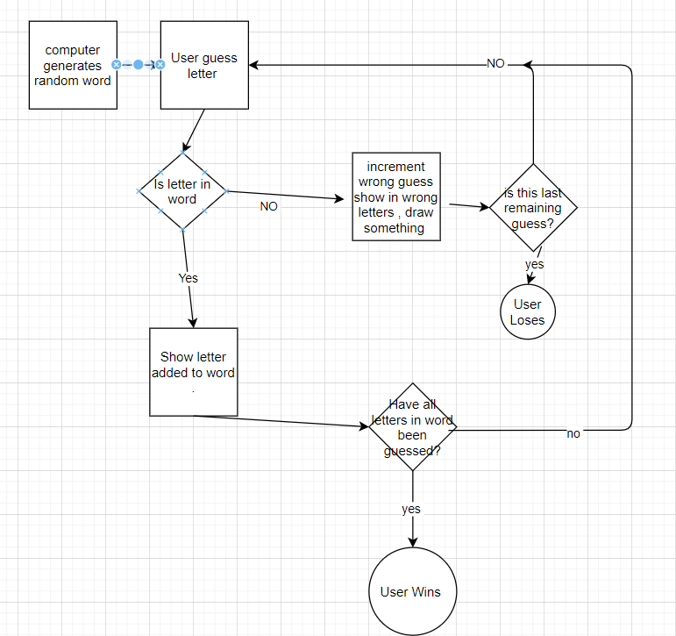

Angelas

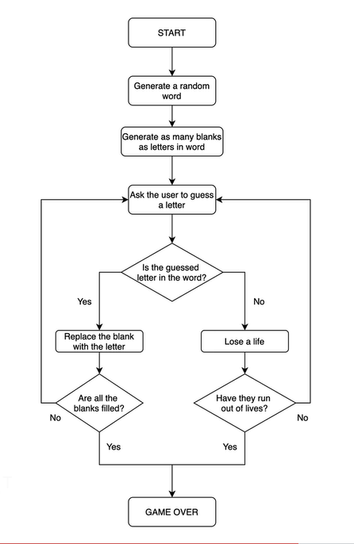

Python docs For and In use in lists

<https://developers.google.com/edu/python/lists#for-and-in>

#Step 1

word_list = ["aardvark", "baboon", "camel"]

#TODO-1 - Randomly choose a word from the word_list and assign it to a variable called chosen_word.

import random

chosen_word = random.choice(word_list)

#TODO-2 - Ask the user to guess a letter and assign their answer to a variable called guess. Make guess lowercase.

guess = input("Guess a letter: ").lower()

#TODO-3 - Check if the letter the user guessed (guess) is one of the leters in the chosen_word.

for letter in chosen_word:

    if letter == guess:

        print("Right")

    else:

        print("Wrong")

Replacing the Blanks with Guesses

<https://developers.google.com/edu/python/lists#range>

#Step 2

import random

word_list = ["aardvark", "baboon", "camel"]

chosen_word = random.choice(word_list)

#Testing code

print(*f*'Pssst, the solution is {chosen_word}.')

#TODO-1: - Create an empty List called display.

#For each letter in the chosen_word, add a "_" to 'display'.

#So if the chosen_word was "apple", display should be ["_", "_", "_", "_", "_"] with 5 "_" representing each letter to guess.

display =  []

word_length = len(chosen_word)

for _ in range(word_length):

  display += "_"

print(display)

guess = input("Guess a letter: ").lower()

#TODO-2: - Loop through each position in the chosen_word;

#If the letter at that position matches 'guess' then reveal that letter in the display at that position.

#e.g. If the user guessed "p" and the chosen word was "apple", then display should be ["_", "p", "p", "_", "_"].

# need the position where the match occured

for position in range(word_length) :

  letter = chosen_word[position]

  if letter == guess:

      display[position]=letter

#TODO-3: - Print 'display' and you should see the guessed letter in the correct position and every other letter replace with "_".

#Hint - Don't worry about getting the user to guess the next letter. We'll tackle that in step 3.

print(display)

resume 71 check if play won

need a while statement and for in

<https://developers.google.com/edu/python/lists>

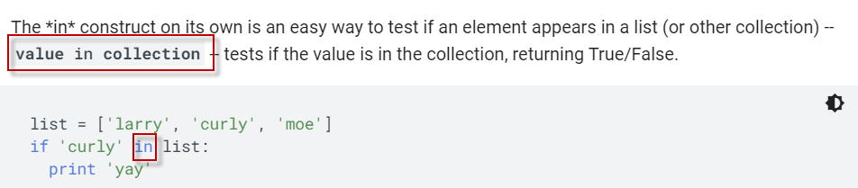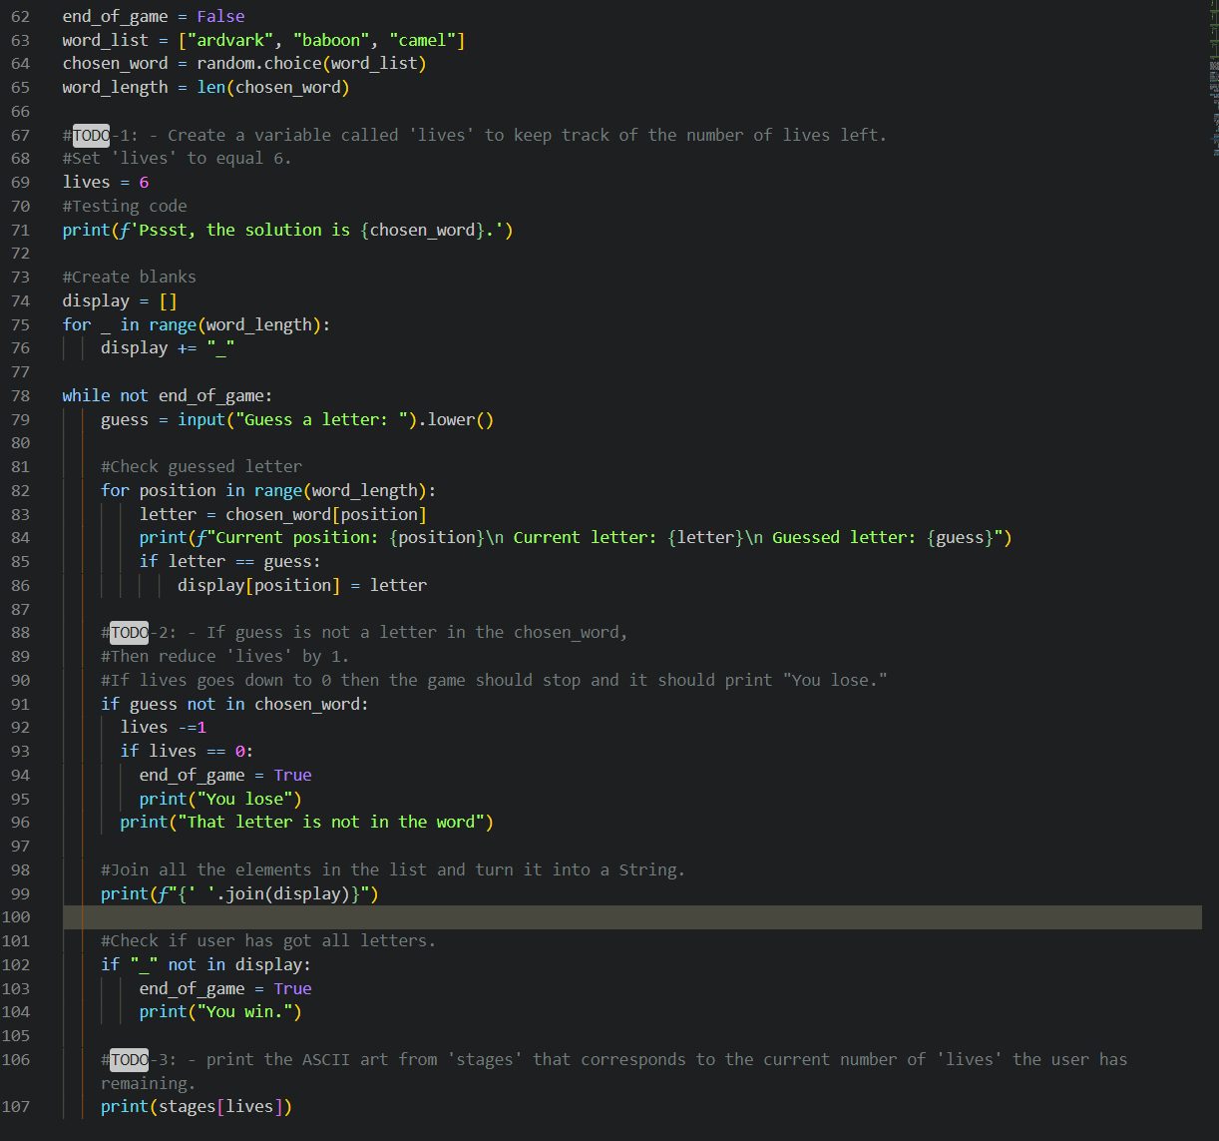

**Syntax for importing a variable from another file** 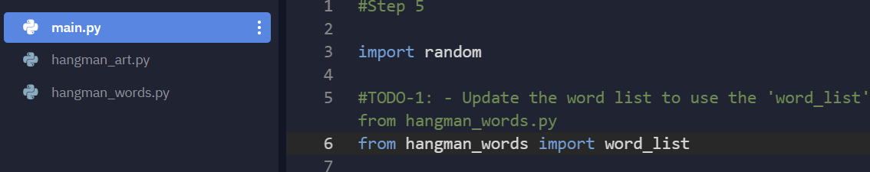

Better syntax for importing if it is for things from same file

